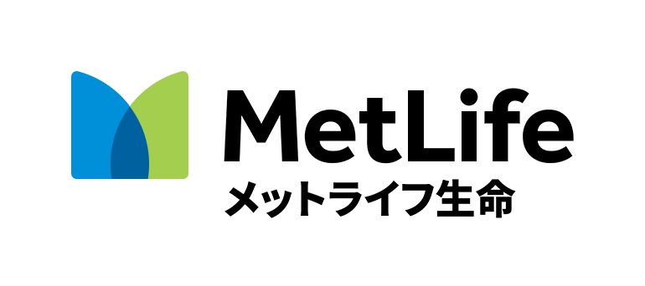

TOMODACHI MetLife Women’s Leadership Program

Mentor (Professional) Application Form
Section 1: Personal & Contact Information
1. Name (First Last)
2. Program City you are applying for. (circle one)
Tokyo Osaka Naha Sapporo
3. How did you hear about this program? If someone recommended that you apply, please provide their name and organization.
4. Total number of years of work experience. | 5. Current Position Title | 6. Current Employer/Company
7. Email Address  NOTE: Provide an email address that you use regularly. We will send your application results via email. |  | 8. Phone Number
9. Mailing Address (including zip code)
10. Previous work experience (including professional work abroad).
11. Hobbies and personal interests.
12. Previous study abroad or work experience abroad. |  | 13. University and major at graduation.
Section 2: Interest and Qualifications
14. Short Essay: What excites you most about being a mentor in this program?
Please write a response in English in 150 words or less.
15. Short Essay: What do you want to contribute; what experience, knowledge, skills, and resources can you offer participants in this program?
Please write a response in English in 150 words or less.
Section 3: Availability & Background
16. Are you available to participate in all program workshops assigned to the mentor in your city, and can meet with your assigned mentee outside of formal program sessions? (circle one)
Note: Mentors do not have to attend all five workshops. Please refer to the program webpage at www.usjapantomodachi.org to view attendance requirements.
Yes, I’m available to fully participate in this program. No, I’m not.
17. Name of any other TOMODACHI program(s) you are participating in now or that you are applying for.
18. Name of any other TOMODACHI program(s) you have participated in in the past.
Please submit your applications via email by midnight June 18, 2018 to your local TMWLP office:

Tokyo Area: Submit applications to: TokyoTMWLP@usjapancouncil.org
Osaka Area: Submit applications to: KansaiTMWLP@usjapancouncil.org
Naha Area: Submit applications to: OkinawaTMWLP@usjapancouncil.org
Sapporo Area: Submit applications to: SapporoTMWLP@usjapancouncil.org

The results will be announced by August 17, 2018.

