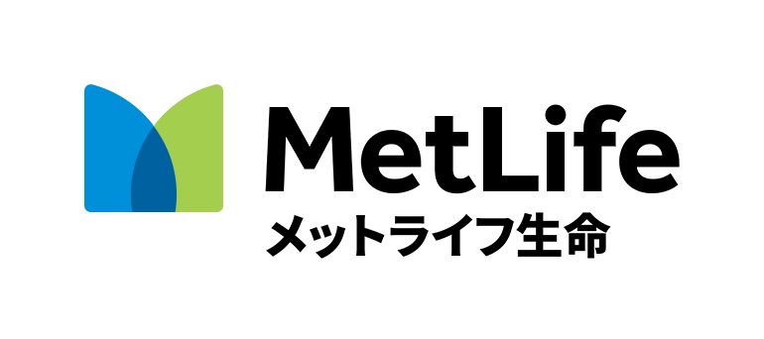

TOMODACHI MetLife Women’s Leadership Program

Mentee (Student) Application Form
Section 1: Personal & Contact Information
1. Name (First Last)
2. Program City you are applying for (circle one)
Tokyo Osaka Naha Sapporo
3. How did you hear about this program? If someone recommended that you apply, please provide their name and organization.
4. Year in School (1st, 2nd, 3rd) | 5. Major | 6. University
7. Email Address  NOTE: Provide an email address that you use regularly. We will send your application results via email. |  | 8. Phone Number
9. Mailing Address (including zip code)
10. If you have ever lived or studied abroad, please describe your experience.
11. Hobbies and personal interests.
Section 2: Interest and Qualifications
12. Short Essay: Considering your future plans (after this program and beyond), what excites you most about being a part of this program? And, how do you think this program will help you achieve your goals?
Please write a response in English in 150 words or less.
13. Short Essay: What is one problem or challenge (societal, professional/academic, or personal) that you feel passionate about solving and why?
Please write a response in Enlgish in 150 words or less.
Section 3: Availability & Background
14. Are you available to participate in all proogram workshops in your city?
Note: Please refer to the program webpage at www.usjapantomodachi.org to view attendance requirements.
Yes, I’m available to fully participate in this program. No, I’m not.
15. Name of any other TOMODACHI program(s) you are participating in now or that you are applying for.
16. Name of any other TOMODACHI programs you have participated in in the past.
Please submit your applications via email by June 18, 2018 to your local TMWLP office:

Tokyo Area: Submit applications to: TokyoTMWLP@usjapancouncil.org
Osaka Area: Submit applications to: KansaiTMWLP@usjapancouncil.org
Naha Area: Submit applications to: OkinawaTMWLP@usjapancouncil.org
Sapporo Area: Submit applications to: SapporoTMWLP@usjapancouncil.org

The results will be announced by August 17, 2018.

