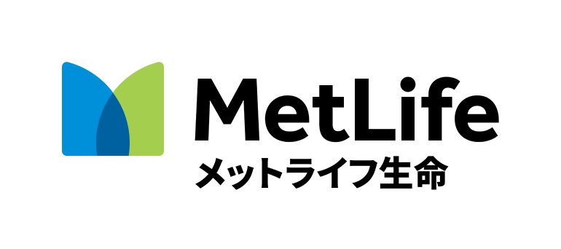

TOMODACHI MetLife Women’s Leadership Program

Mentor (Professional) Application Form
Program City you are applying for (Tokyo, Osaka, Naha, or Fukuoka)
Last Name | First Name | Date of Birth (MM/DD/YEAR)
Employer/Company/Organization | Position Title | Number of years of work experience
Email Address |  | Phone number
Mailing address (including ZIP code)
Previous work experience (including any professional experience abroad)
University and Major (including any study abroad experience)
Hobbies and personal interests.
In what way would you most like to help the future generation of Japanese women? Please write a response (in English) in 100 words or less.
Why do you want to serve as a mentor and how would you plan to engage with your assigned mentee outside of the formal program meetings? Please write a response (in English) in 100 words or less.
Please submit your applications via email by June 26, 2017 to your local TMWLP office (see below):
Tokyo Area: Submit applications to: TokyoTMWLP@usjapancouncil.org
Osaka Area: Submit applications to: KansaiTMWLP@usjapancouncil.org
Fukuoka Area: Submit applications to: KyushuTMWLP@usjapancouncil.org
Naha Area: Submit applications to: OkinawaTMWLP@usjapancouncil.org
The results will be announced by August 14, 2017.

